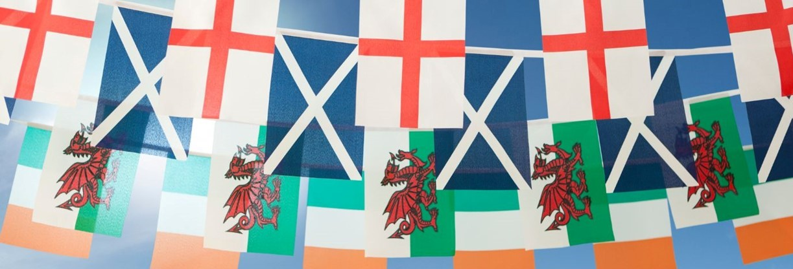
British Dressage Para Home Nations
Para Home Nations 18th-20th May 2023
Open to Para riders aged 12yrs & over, members of
British Dressage & Dressage Ireland
Home Nations Team Championship

Onley Grounds Equestrian Complex
Willoughby, Rugby, CV23 8AJ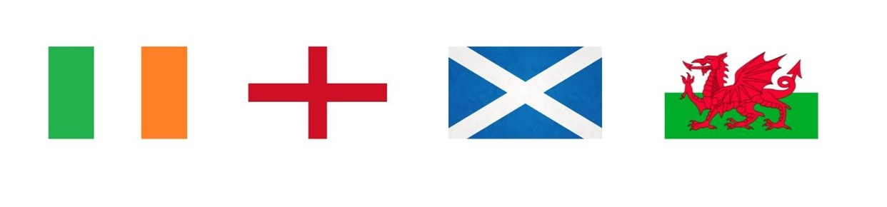
Schedule for Para Home Nations
Venue Contact Information
Secretary: Sarah Jacklin
Onley Grounds Equestrian Complex
Willoughby
Rugby
CV23 8AJ
(0)1788 817724
sarah@onleygroundsec.com

Thursday 18th May 2023 – Arrival Day – Time table
All horses must have a valid passport and vaccinations up to date (in accordance with the BD members handbook 2023 rule 11 page 61.
12:00 – Stables open to all competitors unless you have arranged to arrive on Wednesday.
15:00 – Trot up of all PHN Team horses. An order will be given to Development Officer or PARA Rep, prior to arrival. Please ensure hard hats are worn along with suitable footwear.
16:30–18:00 Arena Familiarization which will be stewarded. This is to be completed in Grades, with agreed time slots.
17:00 - Chefs Meeting in Forge restaurant.
19:00 - Parade of Teams. Regions & Teams are encouraged to bring a team mascot and wear team clothing.
19:30 - Drinks & canape reception

Team briefings organised by your Development Officer or PARA Rep.

Prizes
Rosettes, sashes, and trophies will be presented to the winning team of the two days.
Rosettes will be presented to teams placed 2nd to 10th place.
Commemorative stable plaques for all competitors
The Marian Bach Shield and Kings Trophy will be awarded to the winning team.
An overall Individual Champion will be awarded from the two -day competition for
- Grade 1
- Grade 2
- Grade 3
- Grade 4
- Grade 5
Sash and rosette awarded to the highest placed rider in each grade.
All competitors should attend prize giving; failure to do so may result in prizes being handed down to the next placed team.

Thursday 18th May

A full open PARA schedule with qualifiers will run on the morning of Thursday 18th May, before the trot up. This schedule can be entered as usual via schedules and fixtures on BD online.

Friday 19th May – Para Home Nations Day One

For the Team Class, Home Nations Riders must enter Friday class numbers 1-15, as this is a two-day competition.

Saturday 20th May – Day Two

For the Team Class, Home Nations Riders must enter 16-30 for Saturday, as this is a two-day competition. The closing ceremony will take place after the team tests have concluded on Saturday.

Class Schedule:

Home Nations Classes 1 to 15 on Friday 19th May

Tests for Home Nations Para (Bronze HN Riders)
Class 1 - Grade 1 BD Intro test 2023
Class 2 - Grade 2 BD Intro test 2023
Class 3 - Grade 3 BD Intro test 2023
Class 4 - Grade 4 BD Intro test 2023
Class 5 - Grade 5 BD Intro test 2023

Novice Test for Home Nations Para (Silver HN Riders)
Class 6 - Grade 1 FEI Intermediate test A 2023
Class 7 - Grade 2 FEI Intermediate test A 2023
Class 8 - Grade 3 FEI Intermediate test A 2023
Class 9 - Grade 4 FEI Intermediate test A 2023
Class 10- Grade 5 FEI Intermediate test A 2023

Team Test for Home Nations Para (Gold HN Riders)
Class 11 – Grade 1 FEI Grand Prix A test 2023
Class 12 – Grade 2 FEI Grand Prix A test 2023
Class 13 – Grade 3 FEI Grand Prix A test 2023
Class 14 – Grade 4 FEI Grand Prix A test 2023
Class 15 – Grade 5 FEI Grand Prix A test 2023

Home Nations Classes 1 to 15 on Saturday 20th May
Home Nations Classes 16 – 30 on Sunday

Tests for Home Nations Para (Bronze HN Riders)
Class 16 - Grade 1 BD Intro test 2023
Class 17 - Grade 2 BD Intro test 2023
Class 18 - Grade 3 BD Intro test 2023
Class 19 - Grade 4 BD Intro test 2023
Class 20 - Grade 5 BD Intro test 2023

Novice Test for Home Nations Para (Silver HN Riders)
Class 21 - Grade 1 FEI Intermediate test A 2023
Class 22 - Grade 3 FEI Intermediate test A 2023
Class 23 - Grade 3 FEI Intermediate test A 2023
Class 24 - Grade 4 FEI Intermediate test A 2023
Class 25 - Grade 5 FEI Intermediate test A 2023

Team Test for Home Nations Para (Gold HN Riders)
Class 26 – Grade 1 FEI Grand Prix A test 2023
Class 27 – Grade 2 FEI Grand Prix A test 2023
Class 28 – Grade 3 FEI Grand Prix A test 2023
Class 29 – Grade 4 FEI Grand Prix A test 2023
Class 30 – Grade 5 FEI Grand Prix A test 2023

Saturday 20th May 2023 – Demo and BBQ
Tickets for the Demo and (£20) & for the BBQ dinner (£18) are available to book via my riding life.

Times Times for the Para Home Nations will be posted on my riding life and a link on the Onley Ground EC Facebook page to the times on Tuesday 17th May 2023.

Teams Teams will be made up of 3 or 4 horse & rider combinations; these can be Bronze, Silver & Gold riders. No Team may contain more than two riders from any one grade.

The Team results are calculated as follows: In all team competitions the winning team is the one having the highest percentage. Percentages from both days will be added together and the scores added together of their three best athletes, the second placed team is the one with the next highest percentage and so on. In case of equality of percentages, the winning team is the one (1) who’s third placed athlete out of the best three (3) has the best result.

At the end of day one overnight results will be posted. The Chefs for each team must check their team’s results and any anomalies reported to the Secretary without delay. On the second day a 30-minute time allocation will be made for Chefs/a regional representative to meet the scoring team and check the results prior to publication and prize giving.
Entry Fees
£80 per rider / team competition tests, and to include welcome drinks & canapés, free entry at the demo evening on Saturday night.
dinner on Friday night, will be at a cost of £15 per person.
Demo night dinner will be a BBQ with salads at £18 per person.
£25 for warm up classes.

Withdrawals/Refunds
Please note that after the definite entry date no refunds can be made.

Entries Close:
5th May 2023 – no late entries and all entries for PHN will be online via. My riding life. information will be sent via your DO after selection has been announced.
Substitutions will be accepted after close of entries until 15th May. However, no refunds will be given.

Lorry Park:
There is ample parking for Lorries. Hook up is available at the fee of £30 per night, this must be pre-booked, and is payable with entries/stabling.

Stabling:
A mixture of on-site permanent and temporary stabling.
Permanent stables are supplied will some shavings and must be left swept and banked up.
Temporary stables are empty and must be left clean and banked up.

Shavings Only – These can be purchased from us at £10.70 a bale or pre ordered via my riding life. You are welcome to bring your own.

Stables are allocated in regions where possible (except for stallions) and stable plans will be clearly visible on arrival. Please indicate on entry form time of arrival. Stabling will be available from Wednesday evening for those wishing to arrive early, an arena will be made available for general exercise on Thursday morning.
The stable office will be open until 7pm each evening.

Stabling cost:
Two nights at £105 and £25 for any extra night. (Please notify in advance if you require longer)
Please be on site before 7.00pm if you wish to purchase/collect bedding.
Please state if you require a stallion stable.
Stable Deposit - £10.00 cash deposit per stable to be paid on arrival, then returned prior to leaving stable clean and inspected by Stable Manager.

Arena Walks
Arena walks will be available and will be scheduled in, your Chef D ’equipe will be advised of times, and time will be published on Facebook along with start times. This is in walk and can be either mounted or unmounted with competition number worn, and OUTSIDE the arenas.
Exercise of Horses
There is one arena for working in and for exercise for horses not warming up for their classes, space permitting. The competition arena is also indoors.
Bridle numbers must be worn at all times.

General Rules
Normal BD Para championship rules apply. No commanders are permitted in any test unless specified on the riders classification. Grading points will not be awarded. Riders must be eligible to ride at the level which they intend to compete in accordance with the rules above. One whip is permitted for a para at all times. This is as per rule 18 page 66 of the BD rules book, FEI classification will take priority when referring to compensating aids.
FEI Classification supersedes National Classification in respect of compensating aids.
Biography Forms
Please complete and return by e-mail (sarah@onleygroundsec.com) These are also attached to this email. These should be returned no later than two days prior to your competition date.

Officials
The event will be stewarded in accordance with BD championships and a Ground Jury appointed. In the event of any technical or competition issues the Chef for each region should address the ground jury in the first instance.

Chef D’equipe
There will be a Chef d’equipe meeting on Thursday 18th May 17:00. Contact details of all Chef d’equipe should be sent to Onley Grounds EC with entries, prior to arrival.

Vet/Farrier
Vets contact details – Towcester Equine vets – 01788 523000 and will be posted at the secretary’s office.
Although not on site, farrier will be on call, please speak to the secretary for a phone number – please however ensure that your horse/pony is well shod.
Dogs
Dogs are NOT allowed in the competition arenas or warm up arenas. Dogs MUST always be kept on leads and owners must clear up after them.

Entertainment
Parade of Teams on Thursday night at 7pm in the Large indoor Arena, followed at 7.30pm by drinks and canapes in the Forge restaurant.
Friday night we will be providing dinner at £18, If you wish to purchase dinner tickets, this can be done with entries/stables/hookup.
Saturday night we have a Gala evening, which is free to competitors. Should you wish to purchase BBQ dinner tickets, they are available online via my riding life with entries/stables/hookup.

Food & Drink
Café will be open from 1 hour before the first test, until 18:00
Restaurant is available to book online via www.thechukkabar.co.uk

Conditions of Entry
- All riders must be a paid member of British Dressage.
- Riders in GSB must be Full Members (12 and over on 1 January 2023) of British Dressage or Dressage Ireland.
- Horses/ponies must be 5 years or over and have a full British Dressage Membership
- Riders must be eligible to compete in the bronze, silver, or gold section in accordance with BD rules, Rule 177 of BD Members’ Handbook 2023
- Riders must have a national classification. FEI classification is not compulsory.
- One rider on each team may have competed in a CPEDI 3* since January 2018. Riders who have competed in a World, European or Paralympic Championships are not eligible.
- Riders are required to attend regional training days in line with the Regional Selection Policy and submit test sheets by the required date, from the last 12 months of BD and/or RDA dressage competitions to their Para Rep or Regional Development Officer • No grading points will be awarded for this competition.
- All horses must be vaccinated as per rule 11 of the BD Members’ Handbook 2023
All competitors must attend the prize giving; failure to do so may result in prizes being handed down to the next placed team.

Dress Code
In accordance with British Dressage rules 2023.
Those selected to compete as team members are entitled to wear their nation’s pocket badge (England, Ireland, Scotland, or Wales – NB not the Union flag) on their competition jacket and saddle cloths for the duration of the Home Nations. Flags to be removed immediately after the competition. Flags must be fixed onto the left breast of the competition coat. Flags should also be worn on saddle cloths for the competition.

General Entry Information
Entries must be submitted by the Regional Development Officer or the Para Rep from each region on the official entry form supplied.
Toilets and Shower Facilities

The toilets and showers are always open.

Photographer
https://www.emmpix.co.uk will be attending to capture each combinations test.

Trade stands
There will be a range of trade stands on the courtyard, we also have an onsite tack shop.

Social Media
To keep up to date on all of our plans between now and the competition, you might wish to ‘like’ our https://www.facebook.com/Onleygroundsec

All that is left, is to wish you a successful and enjoyable time with us at Onley Grounds EC.
Best wishes,
Sarah & The Team at Onley Grounds EC.
Directions – Google Maps Link - https://goo.gl/maps/bb89nJwVSKKpooGs7
Using a Sat Nav:
Some Sat Navs when using the CV23 8AJ post code, miss the exit of the M45
Use the Post Code CV23 8AH, this will take you to the top of the drive, head for Onley Equine Vets.

From M1 (Coming from the North)
Come off of the motorway at Junction 18. At the roundabout turn towards DIRFT
Next roundabout turn left
Next roundabout go straight over (Eddie Stobart on your left)
Next roundabout turn left onto A5.
Follow this road up into Kilsby
At the roundabout follow the A361 (to the right) through Kilsby
Once out of the village go over the M45 bridge, follow A361 towards Daventry
At roundabout take 3rd exit following the A361 towards A45
At roundabout take 2nd exit towards Dunchurch, Coventry, Rugby A45
Follow the A45 you will pass the following villages whilst on A45 Braunston & Willoughby
Pass the right turn for HM Prison Onley & Onley village.
The next right turn is for Onley Grounds Equestrian Complex

From M4
Leave the M4 at junction 13 onto the A34 north (Oxford)
Eventually, join the M40 (junction 9) to go north (first exit off of the A34/M40 roundabout)
Leave the M40 at junction 11 (Banbury), travel towards Banbury
At the Tesco roundabout, turn right onto the A423 (Southam)
On the outskirts of Southam, turn right onto the A426 (Rugby and Dunchurch)
In Dunchurch, at the traffic lights, turn right onto the A45
Follow the A45 until you reach the signposted entrance to Onley Grounds EC.

From M1 (Coming from the South) and Coventry A45
Leave the M1 at junction 17 onto the M45
At the end of the M45 go round the roundabout and back onto the M45
The exit junction can only be accessed southbound
Leave the M45 at the first exit, signed A45
Turn right at the exit roundabout onto the A45.
Follow the A45 until you reach the signposted entrance to Onley Grounds EC.

From M5
Leave the M5 at junction 9 onto the A46 eastbound (Ashchurch, Evesham, Stratford). Be aware of your speed – numerous fixed and mobile speed cameras!
Numerous roundabouts, but stay on the A46
Eventually (on the Kenilworth Bypass), exit onto the A45 towards Coventry Airport, Ryton, Rugby (again, be aware of your speed, numerous fixed and mobile speed cameras)
Join the M45 then take the first exit off of the M45 onto the A45,
At the exit roundabout, turn right onto the A45
Follow the A45 until you reach the signposted entrance to Onley Grounds EC.

